AM,S-PERU-Q’eros-Textiles

Q’eros Textiles

The Q'eros Indian Community, situated between the Andes and the Amazon region, has maintained its cultural identity for more than 500 years after the Spanish invasion. A *Mesa quepe* textile of the Q'ero people, who are perhaps the direct descendants of the Inka[1], called a *Mesa quepe* or *Mastana* (altar cloth) used by Q'ero Paqos or “mystic-shamans” in the ceremony called *despacho, pago a la Pachamama* (“the office of paying homage to the Cosmic Mother”). The *Mesa quepe* was woven in the community of Huacawasi, located in the Calca or “Sacred valley” in the mountains north of Cuzco. This Mastana has interlocking geometrical designs in the form of birds and animals. Since these textiles are hand-loom woven the designs are reversible just as all life has another aspect to it.

The Paqos are neither mystics nor shamans but share certain abilities of each. As mystics they have a spirituality that partakes of a direct, experience of non–duality, an interconnectedness of all beings. A similar concept known as Indra’s net (*Indrajāla* in Sanskrit) is found in Indian philosophy deriving from a metaphor illustrating *pratītyasamutpāda* (dependent origination from the center of the Cosmos).

This concept may be visualized in a spider’s web after a rainfall:

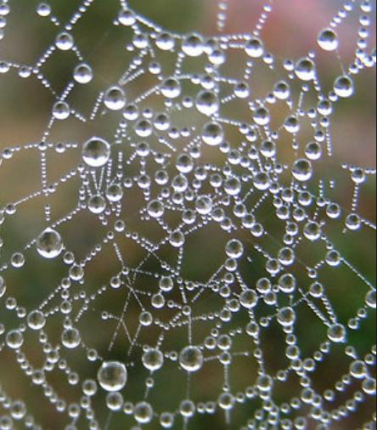

Water droplets suggest both the individuation and the interconnectedness of all Beings with the center from which they are both separate and a part. In the Inka world-view this mutually interactive and supportive relationship of the individual with the center is mirrored in the interconnectedness of the individual withPachamama (Cosmic Mother Earth) and her *Apus* (mountain spirits) in the high peaks of the Andean mountains where they mythically exist. Since Incas *understand* their interconnectedness to Pachamama, they draw on Her power for spiritual energy for service to the community, within the context of *ayni,* the Incan principle where giving and receiving, which are reciprocal. In Q’ero textiles images of creatures are geometrically interlocked, metaphorically indicating that all Beings are interdependent in both giving and receiving. Like shamans, the Paqos develop access to esoteric abilities but unlike shamans they acquire these abilities without entering into altered states of consciousness through the use of psychoactive plants, rhythmic drumming, or group chanting: they derive esoteric abilities like promoting an alpaca’s fertilityby playing flutes and singing heterophonically which has been known empirically to effect the desired result.

**SIZE**: 32 X 34 inches

**MATERIAL**: Alpaca and llama wool

**CULTURE**: Quechua

**ORIGEN**: Cusco- Perú

**COLORS**: Red, burgundy, white, black, and  orange.

1. The spelling “Inka” is used here to reflect the indigenous spelling of the world and its culture rather than the more usual speclling “Tnca” which was transliterated by the Spanish Conquistadores who attempted to destroy the Incan empire and its religiosity through war and missionizing.